**Programming language and framework**

**By Sebastian Bokkestijn**

**Introduction** **2**

**Programming Language & their frameworks** **2**

Python - Django 3

Java - Springboot 4

Java is one of the first programming languages widely renowned for its versatility and incorporating many data science techniques. It is important to consider that the Hadoop HDFS platform for processing and storing big data applications is written entirely in Java. It is an object-oriented language with a C-like syntax that is familiar to many programmers. 4

**The comparison for the languages itself** **5**

Programming Language 5

Web Framework 5

**Conclusion** **6**

# Introduction

This research paper aims to provide insight on the most efficient programming language and framework to deliver the product in and the most suitable for the team.Throughout the research two frameworks and their corresponding languages will be analyzed to determine with which combination the product could be developed more efficiently with and the and the delivery time management of forementioned product.

# Programming Language & their frameworks

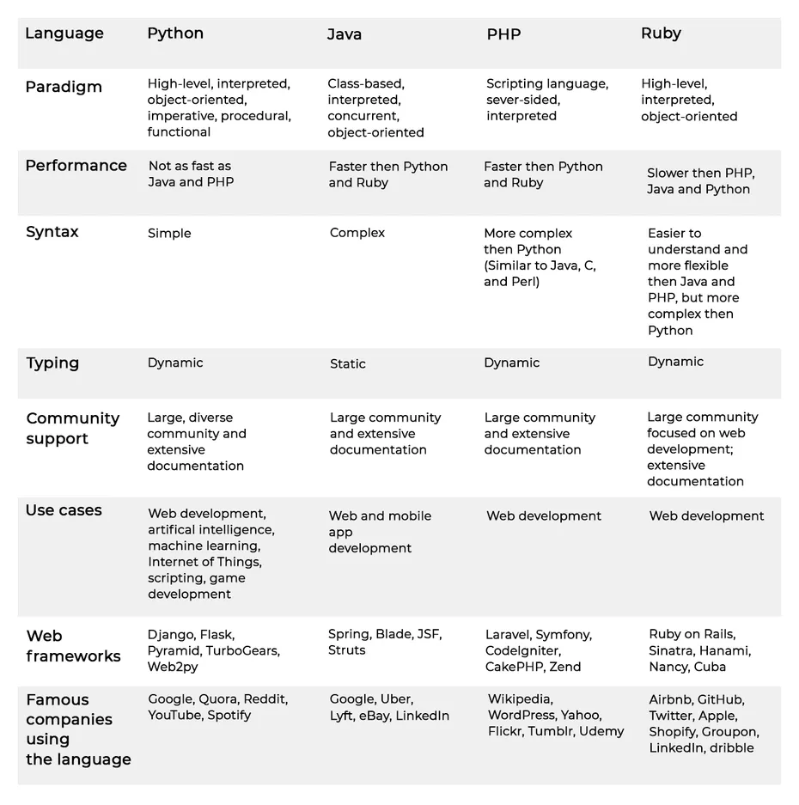

## Python - Django

Python is an interpreted, object-oriented, high-level programming language with dynamic semantics.This means it contains words and phrases comprehensible to humans. To translate this high-level language into machine code, Python uses an interpreter. An interpreter converts source code into code understood by computers. As an interpreted language, Python uses memory efficiently, is easy to debug, and allows developers to perform complex tasks in a couple of steps and edit code quickly.

Python is a dynamic language. This means that developers don’t have to declare variable types. Python verifies types and errors at runtime (when the program is launched), but not during compilation (when source code is converted to machine code). This results in less code, faster development, and greater flexibility and resilience.

First and foremost, it can be used for anything because it offers many features by default, with standard libraries that cover almost any programming task. Whether you’re running scientific calculations, processing images, or developing operating system interfaces or protocols, Python saves time and effort by presenting ready-made solutions.

Since the Python community is open to everyone and encourages diversity, millions of experienced developers around the world contribute to it and add to the growing Python open-source database.

Among Python frameworks, Django is often regarded as the best framework for web application development.

Django was crafted to help build software as quickly as possible. The Don’t Repeat Yourself (DRY) philosophy on which Django is built motivates developers to reuse code they’ve written for other projects, further reducing the time needed to develop your product.

Django’s batteries included approach means that the framework has everything necessary to develop a full-fledged application. Django offers built-in HTML templating, URL routing, object-relational mapping, and session management

## Java - Springboot

## Java is one of the first programming languages widely renowned for its versatility and incorporating many data science techniques. It is important to consider that the Hadoop HDFS platform for processing and storing big data applications is written entirely in Java. It is an object-oriented language with a C-like syntax that is familiar to many programmers.

Spring Boot transforms how you approach Java programming tasks, radically streamlining your experience. Spring Boot combines necessities such as an application context and an auto-configured, embedded web server to make microservice development a cinch.

# The comparison for the languages itself

## Programming Language

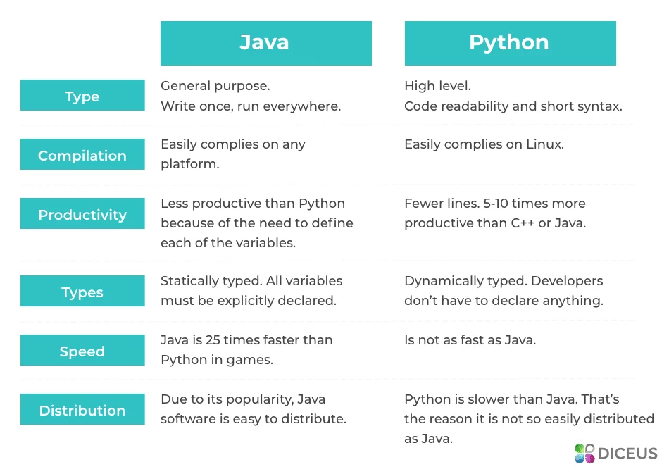

Python is valued for its simplicity and accessibility, especially by AI developers. It is easier to learn and use, and is therefore the preferred choice for programming newbies. You can write two lines on it, but on Java, you need ten. It is suitable for data science but is inferior to Java in performance. When a JVM virtual machine comes into play, nothing can offer the best speed and optimization. The performance difference is significant.

## Web Framework

Django is a high-level Python Web framework that encourages rapid development and clean, pragmatic design; Spring Boot: Create Spring-powered, production-grade applications and services with absolute minimum fuss. Spring Boot makes it easy to create stand-alone, production-grade Spring based Applications that you can "just run". We take an opinionated view of the Spring platform and third-party libraries so you can get started with minimum fuss. Most Spring Boot applications need very little Spring configuration.

"Rapid development", "Open source" and "Great community" are the key factors why developers consider Django; whereas "Powerful and handy", "Easy setup" and "Java" are the primary reasons why Spring Boot is favored.

# Conclusion

Python clearly has the advantage of being able to run a project easily, while Java beats it in speed and efficiency.Python can be used for a wide variety of applications, but its main advantage over Java is its ease of use in data science (big data or data mining), artificial intelligence, and machine learning. However, the goal is to develop a web application and Java seems to be the stronger contender to deliver in this regard.It handles the simultaneous execution of multiple codes better and is more suitable for cross-platform applications

**References**

Medium. (2018, August 28). *When To Use Django (And When Not To)*. Medium. Retrieved September 26, 2021, from https://medium.com/crowdbotics/when-to-use-django-and-when-not-to-9f62f55f693b

Polzer, D. (2021, February 7). Towards data science. Retrieved September 26, 2021, from https://towardsdatascience.com/a-beginners-guide-to-using-djangos-impressive-data-management-abilities-9e94efe3bd6e